SQL PROBLEM STATEMENT

* Create tables given in image (Save create query)

1. CREATE SALESMAN TABLE .

* CODE :-

CREATE TABLE SALESMAN

(

SALESMAN_ID INT(22) NOT NULL,

NAME VARCHAR(40) NOT NULL ,

CITY VARCHAR (100) ,

COMMISSION NVARCHAR (100)

)

SELECT * FROM SALESMAN

* OUTPUT:-

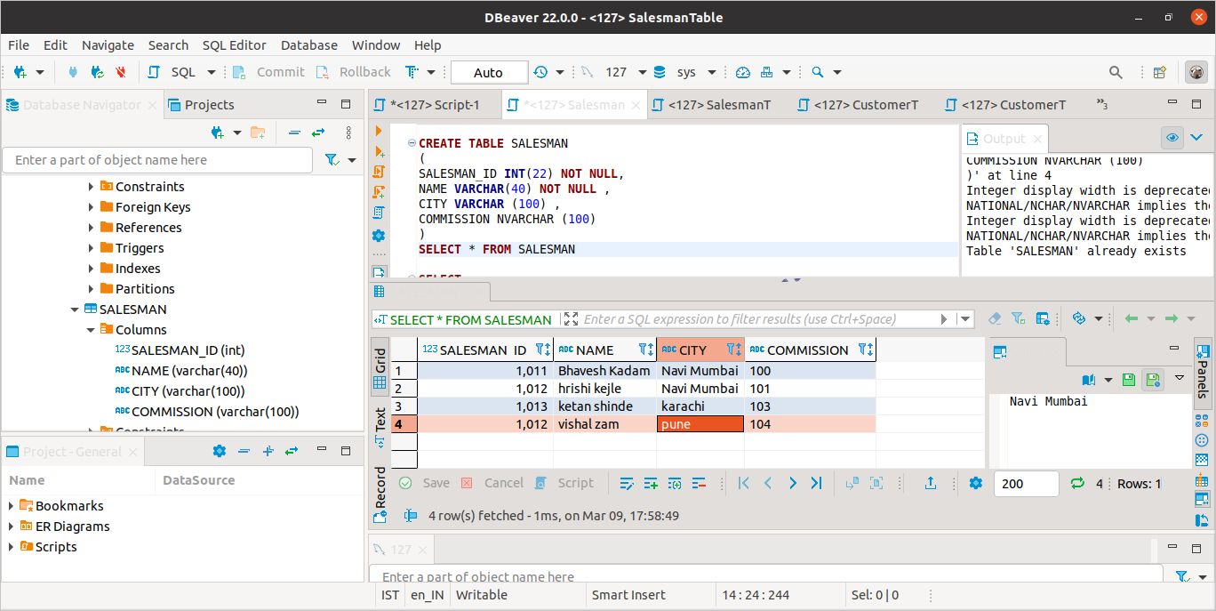

1. CREATE CUSTOMER TABLE .

* CODE:-

CREATE TABLE CUSTOMER

(

CUSTOMER_ID INT(22) NOT NULL,

CUTS_NAME VARCHAR(40) NOT NULL ,

CITY VARCHAR (100) ,

GRADE NVARCHAR (100),

SALESMAN_ID INT (22) NOT NULL

)

SELECT * FROM CUSTOMER

* OUTPUT :-

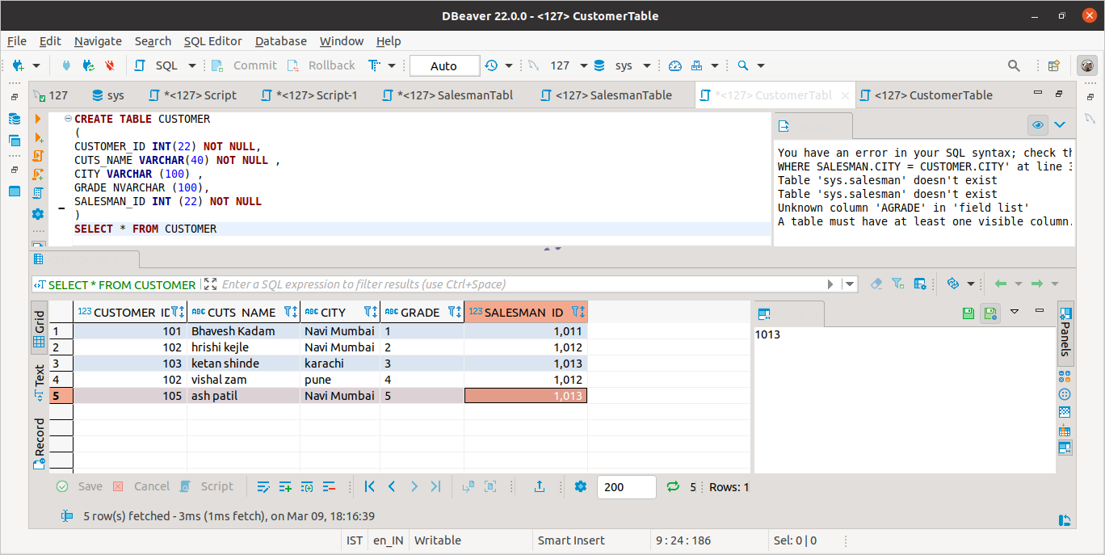

1. Find Salesperson and customer belongs to same city

* CODE :-

SELECT S.NAME, C.CUTS_NAME, S.CITY, C.CITY

FROM SALESMAN S

INNER JOIN CUSTOMER C ON S.SALESMAN_ID = C.SALESMAN_ID

WHERE C.CITY = S.CITY ;

* OUTPUT:-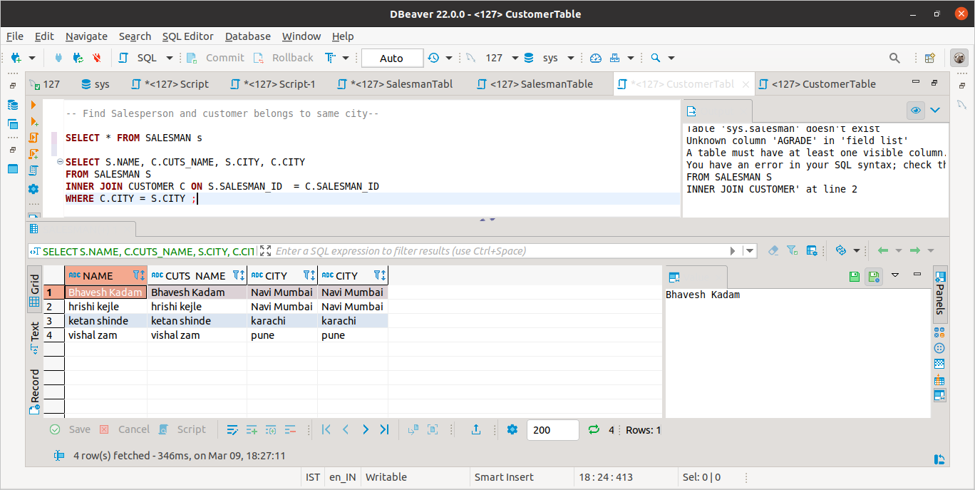

1. List Average commission of a city (in salesman table)

* CODE ;-

SELECT

AVG(ALL GRADE )

FROM

CUSTOMER;

* OUTPUT:-

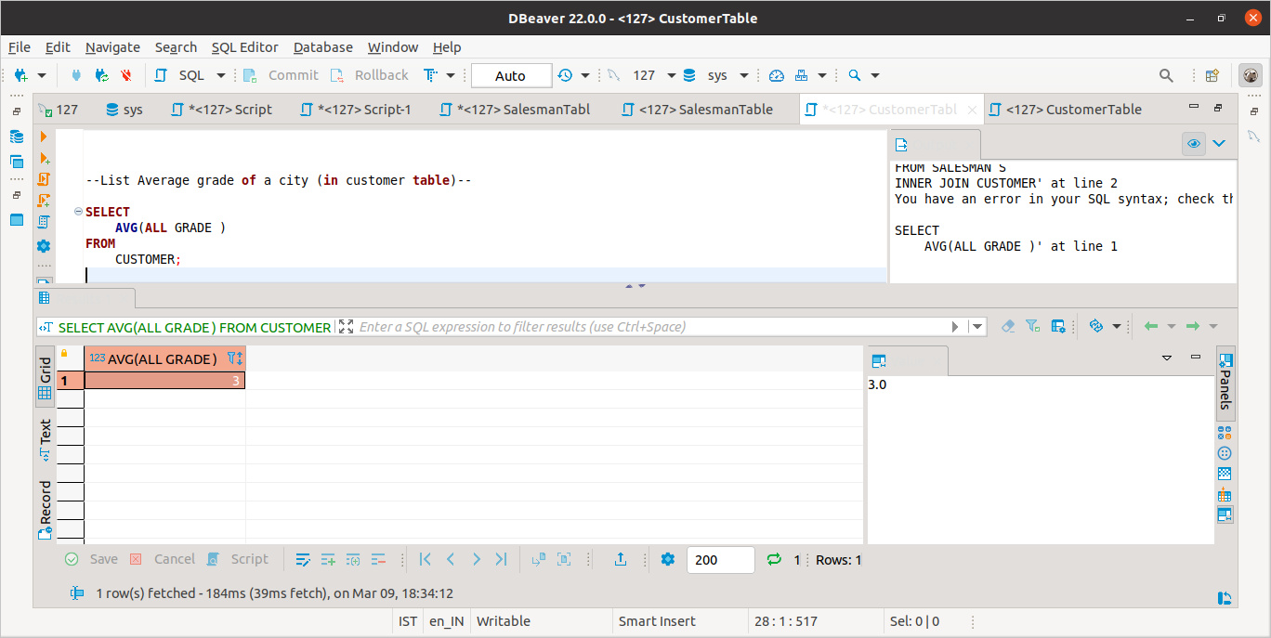

1. Get Details with columns

* Customer_id
* Customer_name
* Customer_city
* Grade
* Salesman_name
* Salesman_city
* Salesman_commission
* OUTPUT:-

